Student Name _________________________________ Song __________________________
Homeroom Teacher ____________________________
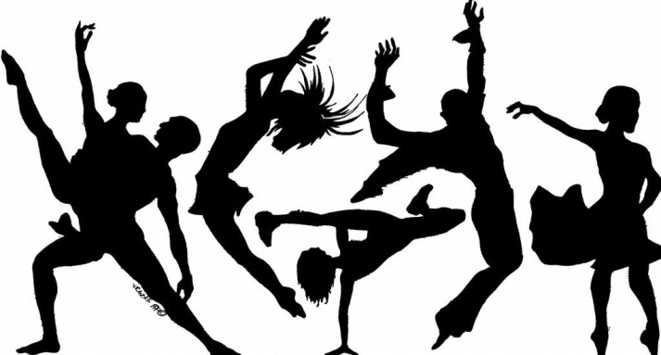
Creative Dance Research

ATTENTION STUDENTS…
You will start your Creative Dance with your team this week.
In order to be prepared and ready to go you need to do some dance moves research.

Research Ideas
- Think of dance moves you have learned in the past and share them with your group.
- Ask your parents about dance moves that they may know and can teach you.
- Check out any of these dance move sites below for some ideas.
  - Minions Dance
https://www.youtube.com/watch?v=OQnVSQoxL10&ab_channel=duptek
- Easy Dance Routine - (Hip Hop Dance Tutorial AGES 7+) | MihranTV
https://www.youtube.com/watch?v=h3DSYn2jIKE&ab_channel=MihranTV
- 34 Minutes of KIDZ BOP Dance Along Videos
https://www.youtube.com/watch?v=sHd2s_saYsQ&t=826s&ab_channel=KIDZBOP
READ THE FOLLOWING CAREFULLY…
You will turn this sheet in with your TWO DANCE MOVES into Coach G DURING your next P.E. class time. This assignment is worth the first 10 points of your grade, so don’t forget to do and turn in your assignment. Also remember what you do or don’t do makes a difference to your team, so make sure you are ready and show your team support
REMEMBER You are not allowed to use any of the six Around the World Dance Party dance moves as your dance move contribution.*

Write your two dance move names below.

1. ________________________________________________

2.________________________________________________

