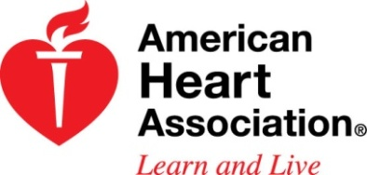
We JUMP & HOOP at Brown Elementary because…
WE CAN MAKE A DIFFERENCE!
Join our campus in the fight against heart disease and stroke!
Jump Rope for Heart is now called Kids Heart Challenge! New name, same great cause and heart-healthy fun. Our students will have the opportunity to be HEART HEROES by learning how to improve their heart health, spreading a heart-healthy message to others, and collecting donations for a great cause! All students are invited to join the American Heart Association in the fight against heart disease and stroke by collecting Kids Heart Challenge donations from February 13th – February 27th.

Donations Due:
Wednesday,
February 27th
Sheyla, age 7
Sheyla was born with a heart condition, called single ventricular cardiac defect. She has had three heart surgeries. One at two weeks old, another at 8 months old, and the last at 4 years old. Sheyla is progressing well and loves to have fun running and playing tag and hide and go seek with her friends. She is able to have lots of fun playing thanks to the research made by the American Heart Association thanks to kids like you donations.

We have some fun things in store!
Along with earning “Thank you” gifts and collecting this year’s heart hero characters…
- Collect any donation amount and earn your name on Brown’s Heart Hero Wall!

- Collect any amount online and sign this year’s Kid’s Heart Challenge Flag!

- $15 or more earns one FREE NASA Space Center Voucher!

- $25 or more earns one FREE Houston Dynamo Ticket and a photo with the mascot!

- $50 or more earns one FREE Houston Rockets Ticket, Rockets t-shirt, and a pass to shoot a post-game free-throw shot!

- $100 or more earns your name on the Morning Announcements, one FREE Houston Astros Ticket, plus a photo with the mascot!

- The 1st Class that has everyone donate in the class wins an Extra P.E. Period and can play the game of their choice!
- The class that has everyone donate & donates the most wins an Extra P.E. Period and can play whatever they want!!

- If we reach our campus fundraising goal of $4,000, Coach Griffin and Coach Sammie will come to school with Crazy Hair for a WEEK!!!
Tip: What is the easiest and safest way to raise money?
Register & Collect Online!
With your parent’s help, log onto www.heart.org/kidsheartchallenge or download the kids heart challenge mobile app and follow the “How to Register” instructions on your Join Our Heart Heroes packet.
Let Us Know if You or a Friend or Family Member Has a Personal Heart Hero Story to Share at School!

